You’re Invited to Join Us
Second Annual Youth Issues Today Conference
13.5 CEUs available, including 4 hours of Ethics and up to 6 hours of Clinical CEUs
Thursday and Friday, Oct. 3-4, 2013 • Cathedral of the Rockies • Boise, Idaho
············································································································································································································
Feature Keynote Speaker:
Julia Cook, MS
Julia Cook was born and raised in Salt Lake City, Utah and now lives in Fremont, Nebraska. She has a Master’s degree in Elementary School Counseling. While serving as a guidance counselor, Julia often used children’s books to enhance her classroom lessons. She is now well-recognized as a national award-winning children’s book author and parenting expert. Julia has presented in over 700 schools across the country, regularly delivers keynote addresses at national education and counseling conferences, and has 36 published children’s books. The goal behind all of Julia’s books and efforts is to actively involve young people into her fun and creative stories and teach them to become life-long problem solvers. Join us as Julia presents on “Unlearning Helplessness and Motivating the Underachiever” and “Survival Kit for Working with Youth”.
Sponsored by the Boise Education Association.

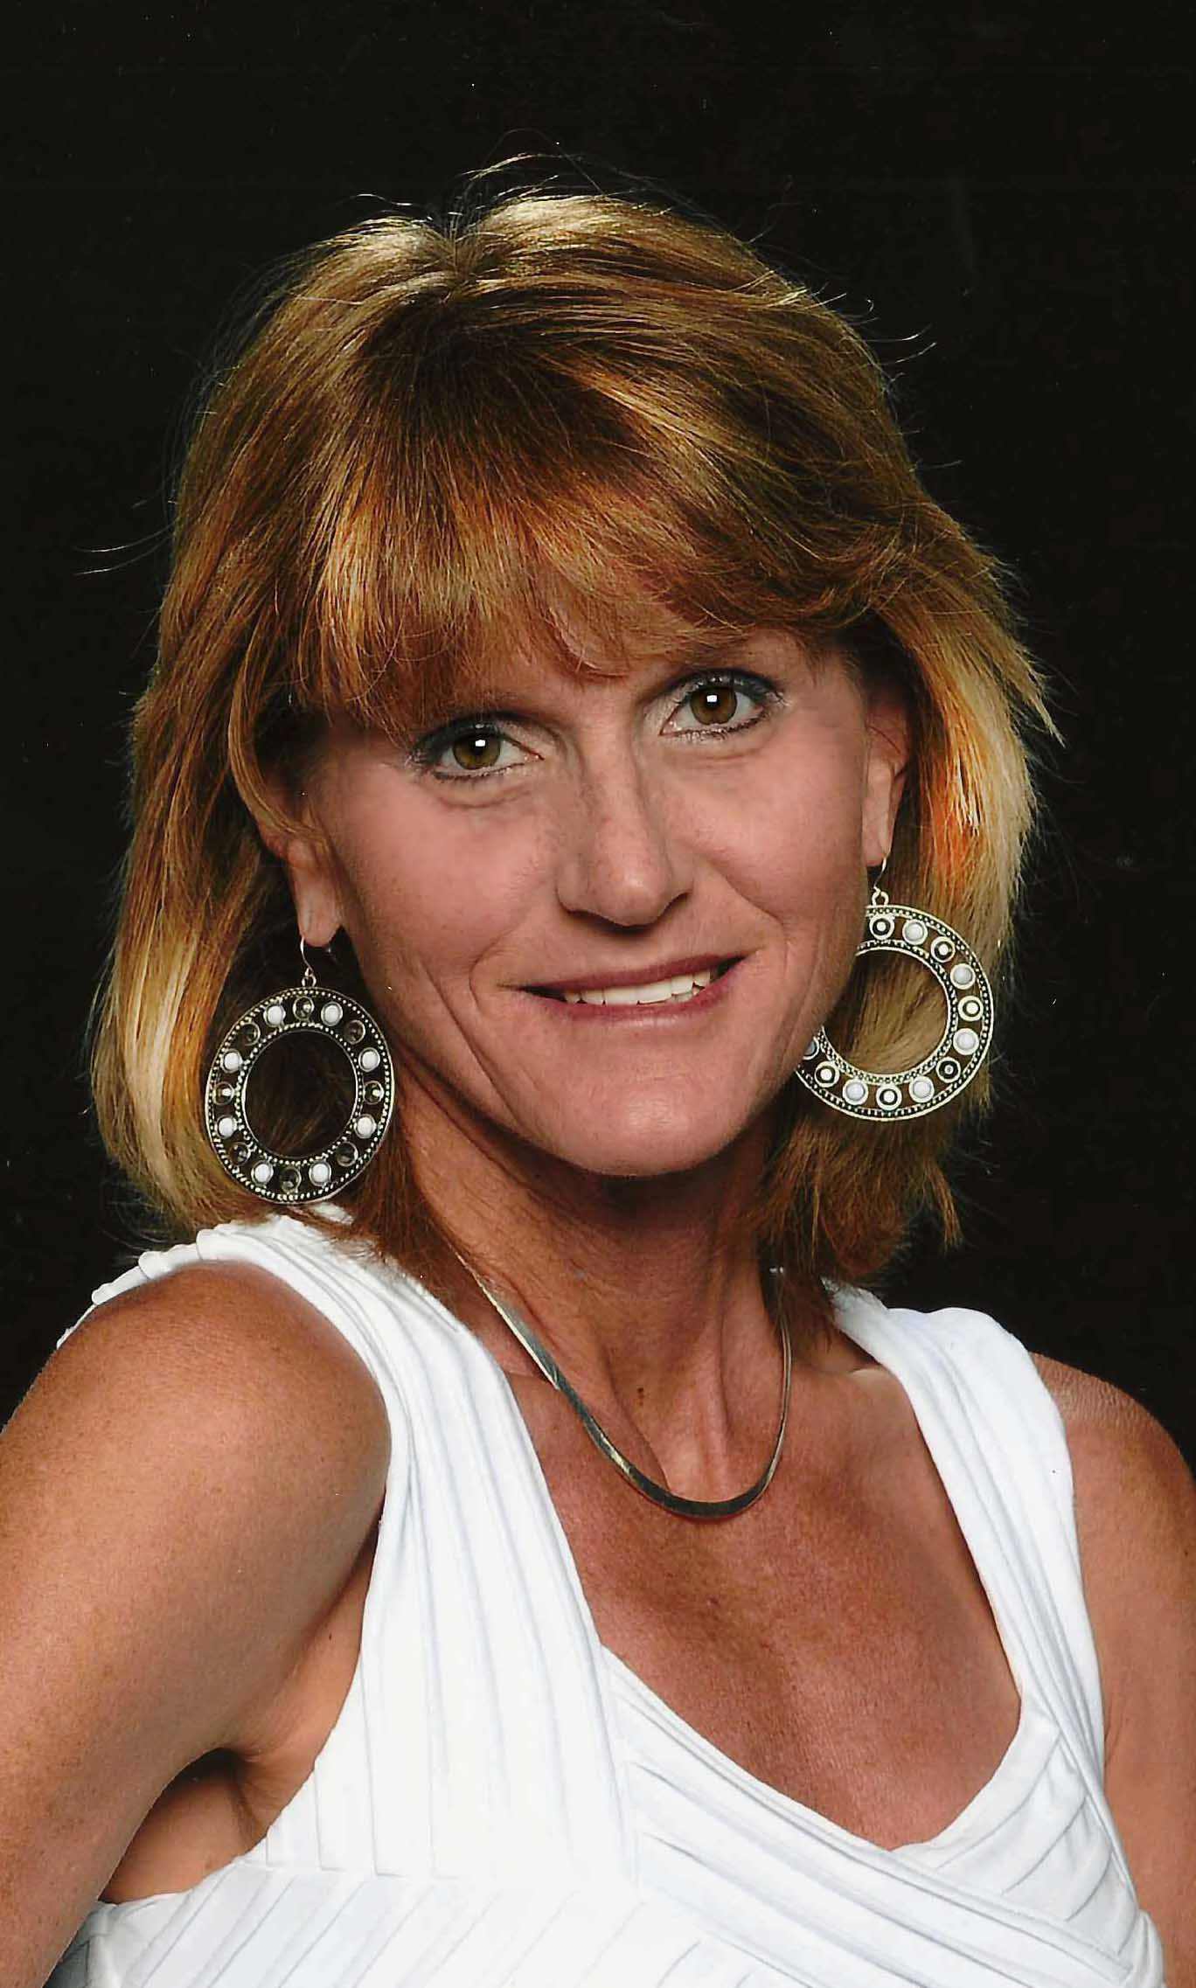
···························································································································································································
General Information
Conference location
Cathedral of the Rockies
717 N, 11th Street, Boise, Idaho 83702

Check-in, registration and continental breakfast
7:30 – 8:00 Check-in and registration. You may register on site with cash, money order or checks only.

Continuing education hours
13.5 CEUs approved by NASW Idaho Chapter. 1 Graduate Professional Education Credit, approved by Boise State University, for an additional $60 to be paid at the conference.

Parking
Currently there is limited parking in the lot directly across from the main entrance on the corner of Hays Street and N. 11th Street. Please visit our website periodically for parking updates: www.schoolsocialworkersofidaho.com

School Social Workers of Idaho
SSWI membership meeting on Thursday, October 3, 11:30 – 1:00. Lunch provided to members only.

For more information:
Visit www.schoolsocialworkersofidaho.com for workshop descriptions and more. Tel: 208-475-4215 E-mail: schoolsocialworkersofidaho@gmail.com

Conference Schedule at a Glance
Thursday, October 3, 2013
7:30-8:00 Check-in, on-site registration and continental breakfast
8:00-11:00 Ethics of Self-Care
11:15-12:45 Lunch on your own/SSWI Meeting
1:00-4:00 Keynote
4:00-5:00 Handout CEU certificates and book signing by Julia Cook
Friday, October 4, 2013
7:30-8:00 Check-in, on-site registration and continental breakfast
8:00-9:30 Session
9:30-9:45 Break
9:45-11:15 Session
11:15-12:45 Lunch Session
12:45-2:15 Session
2:15-2:30 Break
2:30-4:00 Session
4:00-4:15 Handout CEU certificates

Thursday, October 3rd Workshops
8:00-11:00
“Ethics of Self Care,” Delmar Stone, LMSW
Participants will learn common ethical dilemmas in working with youth and explore ethical struggles that may affect ones ability to maintain self-care.
1:00-4:00
“Unlearning Helplessness and Motivating the Underachiever,” Julia Cook, MS
Underachieving occurs when students have a significant gap between their abilities, and what they achieve in school. Participants will learn about the four types of underachievers, explore the characteristics and causes of underachieving, and learn effective solutions that can reverse this problem.
“Survival Kit for Working with Youth,” Julia Cook, MS
Participants will learn tips on how to navigate each and every day successfully; techniques to refocus negative thinking into positive feedback; and how to provide appropriate support to colleagues, clients, and youth during difficult times.
4:00-5:00
Book signing by Julia Cook, MS
Friday, October 4th Workshops
8:00-9:30
1A: A Child’s Journey Through Foster Care: Understanding the Child Welfare Legal System & How it Affects the Child’s Well Being: Lorrie Breshears, LMSW
Participants will explore how child maltreatment and the journey through care can affect the child’s development, mental health and educational well-being. Participants will learn about the service areas that impact each child welfare case; the court process and “team” associated with each case; and how to advocate on the child’s behalf.
1B: Multiple Intelligences and Multi-Sensory Learning: How to Have a Happy Classroom and Successful Students: Laura E. Smith, M.Ed
Participants will learn about the nine intelligences according to the theories of Howard Gardner; explore the concept of multi-sensory education; and practice developing a student-centered environment using skills learned in the workshop.*Approved for clinical level
9:45-11:15
2A: Resistant and Resilient: How Hidden Trauma Influences Childhood Behavior: Janelle Stauffer, LCSW
Participants will explore complex and developmental traumas and gain an understanding of the connection between control seeking behavior and developmental trauma. Various intervention strategies will be discussed. * Approved for clinical level
2B: Navigating the Challenges of LGBTQ Youth: Krista Perry, Melissa Borg, M. Ed., and Ray Mullenax, LCSW
Current issues and hurdles faced by LGBTQ youth and their families will be explored. Participants will learn how to recognize at-risk behaviors and signals, as well as gain invaluable resources to help improve your awareness and provide appropriate support as you navigate the challenges of working with LGBTQ youth in our communities. *Approved for clinical level.
11:15-12:45
LUNCH SESSION: Legislative Advocacy and the Role of the Helping Professional: Delmar Stone, LMSW and Lauren Willis, LMSW
Macro practice for the helping professionals will be explored. Learn how macro work can positively impact the populations you serve and gain an understanding of barriers that may occur when advocating for youth/clients.
**Lunch is provided with your paid registration**
12:45-2:15
3A: Use of DBT-CBT for Work with Adolescents Engaged in Self Destructive Behaviors: Chris Ahlman, Ph.D, MSW
Participants will become familiar with the function behind self-destructive behaviors and the principles of cognitive behavioral and dialectical behavioral therapies and the change process. Learn activities that will help engage youth/clients with self-destructive behaviors and help them move towards positive and empowering behaviors. This is a two-part workshop. *Approved for clinical level.
3B: Planning for Effective Collaboration: Laura Smith, M.Ed.
Participants will compare and contrast the collaborative approach vs. individual accountability and learn how to collaborate more effectively.
2:30-4:00
4A: Use of DBT-CBT for Work with Adolescents Engaged in Self Destructive Behaviors: Continued
4B: Social Work Ethics in the Digital Age: Jennifer Obenshain, LCSW
Identify and explore the potential ethical issues that can arise from social media and other internet advancements.
Conference Fees ·······································································
Conference Fees | Two Days | Thursday Only | Friday Only  (includes lunch)
NASW & SSWI Members  Students | $100 | $60 | $75
Non-Member | $160 | $90 | $115
*Please add $25 for on-site and registration postmarked after 9/24/2013*
Contact us at schoolsocialworkersofidaho@gmail.com for group rate (3 or more registrations from the same agency).
Register online:

https://naswadvocacy.wufoo.com/forms/z7p6p1/

Refund Policy: Contact NASW Idaho prior to the event and request a refund minus a $15 processing fee.

