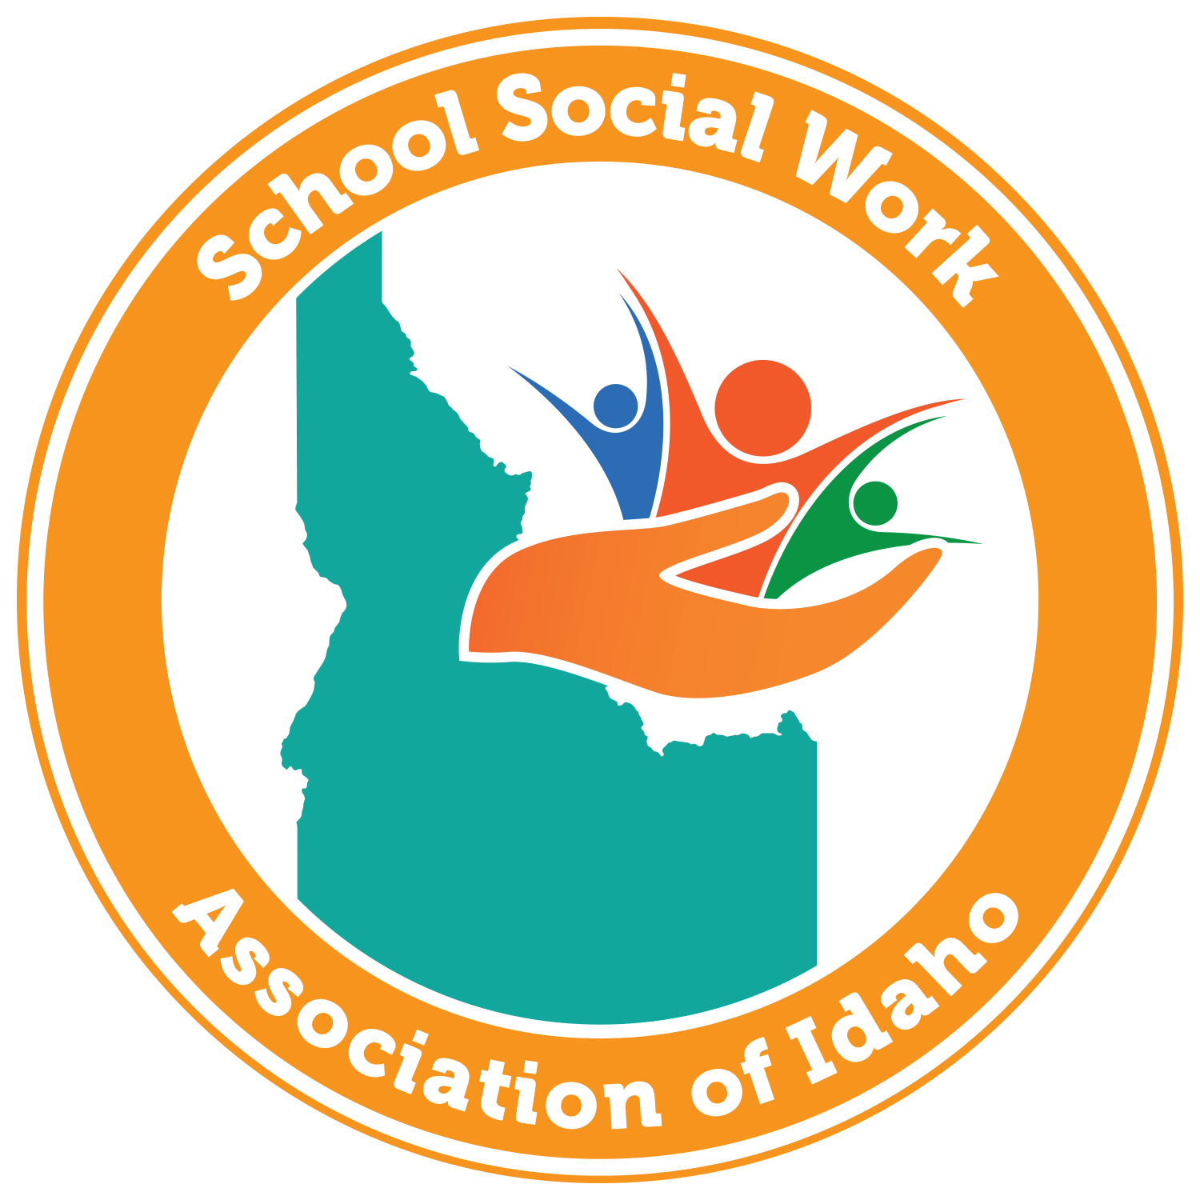 | 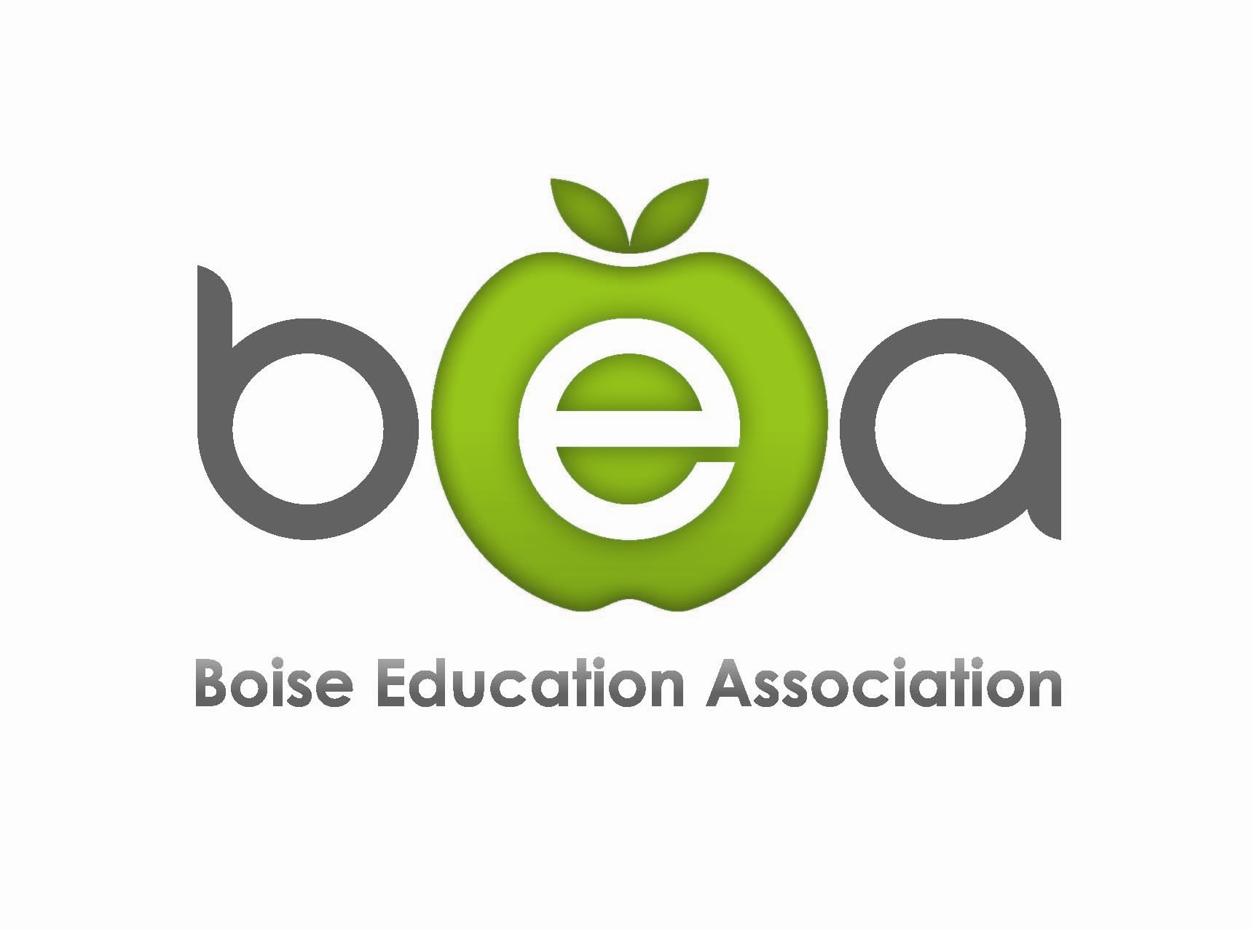
Sixth Annual Youth Issues Today Conference
October 5 - 6, 2017
First Baptist Church Fellowship Hall, 607 N 13th St., Boise, Idaho

FREE with early registration by October 1, 2017

Thursday, October 5th:
“Turning the Tide: Trauma, Resiliency, and Learning”
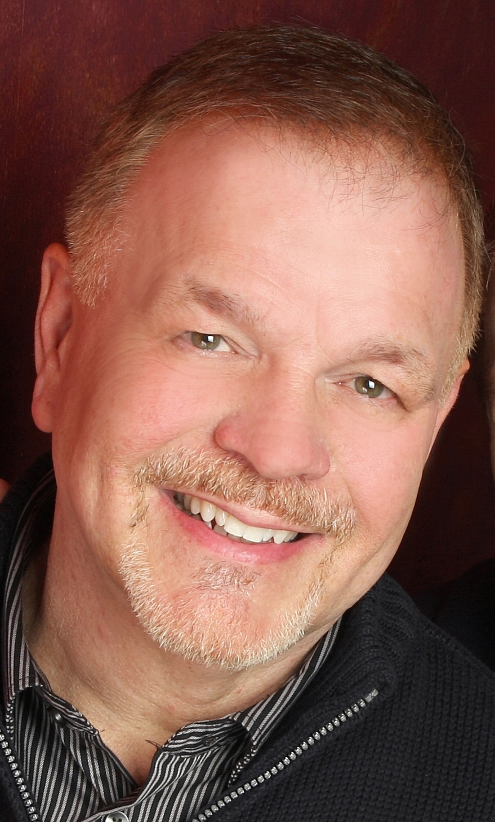  RON HERTEL | Ron Hertel, is a Program Supervisor for Social/Emotional Learning in Student Support at the Office of Superintendent of Public Instruction (OSPI), Washington’s State Education Agency. In 1975, he began teaching in a secure inpatient psychiatric facility for adolescents and part time in a public middle school in Minnesota prior to beginning a 10 year career as a social worker for Boulder County Dept. of Social Services in Boulder, Colorado. In 1989, Ron moved to Washington State where he has supervised a county child welfare office, managed the statewide residential care program for adolescents, and served as program administrator of Children’s Mental Health Services for the Department of Social and Health Services in Washington State. In 2000 he moved to OSPI to bring together his careers as teacher and social worker. He led the development of the Compassionate School Initiative which began in 2008. He was a co-author of a book published in 2009 entitled, The Heart of Learning and Teaching; Compassion, Resiliency, and Academic Success. He also co-authored, Supporting and Educating Traumatized Students: A Guide for School-Based Professionals published by Oxford University Press (2012), and Optimizing Learning Outcomes: Proven Brain-Centric, Trauma Sensitive Practices, published in the spring of 2017 by Routledge (Taylor and Francis Books).

Ron’s workshop will look at the relationship between trauma (Adverse Childhood Experiences or ACES) and the impact on learning by exploring social-emotional skills, being trauma responsive and the art of discipline by connecting before correcting. Participants will gain strategies for building resiliency through classroom implementation, establishing partnerships and achieving school-wide buy-in for sustainability.

Friday, October 6th:
“Self-Regulation IS Self-Care! Essential, Scientific and Compassionate Practices for Every Professional and Student Under the School Roof”

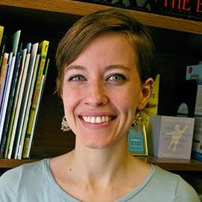JULIE MEEK, LCSW | Julie Meek is a Licensed Clinical Social Worker and the Lead Counselor at Lee Pesky Learning Center. (LPLC) She specializes in individual and group therapy for children, teens, and adults who are struggling to be successful in their academic and personal lives, many of whom suffer from AD/HD, learning disabilities, autism spectrum disorder, executive functioning problems, social cognitive deficits, and mood and anxiety disorders. She has presented locally, nationally, and internationally on her work at LPLC, and has had the honor of sharing self-regulation strategies in several schools in Idaho. She is also a Certified Compassion Fatigue Professional and has a special interest in helping the helper.
Julie’s workshop will look at self-regulation and its impact on academic performance. Participants will learn practical and interactive strategies to improve understanding of and successfully intervene in issues related to dysregulation. Finally, Julie will present self-care practices for restoring compassion satisfaction in school-based professionals.
Conference Registration Information
Conference Location  First Baptist Church Fellowship Hall  607 N 13th St.  Boise, Idaho  Parking is available in the church parking lot. Enter from 13th St. or Franklin.  Certificate of attendance will be available at the end of the conference.  Professional Development Credit  For participants attending both days of the conference, 1 Professional Development Credit is available through BSU for an additional charge (payable to BSU) of $60. Information will be available at the conference.  School Social Work Association of Idaho  SSWAI membership meeting is on Friday, October 6th following the conference.  For more information or questions  E-mail: schoolsocialworkersofidaho@gmail.com  Visit www.schoolsocialworkersofidaho.com | Thursday, October 5, 2017  8:30 - 8:55 Check-in  8:55 - 9:00 Welcome and Introduction  9:00 - 12:00 Presentation  12:00 - 1:00 Lunch on your own  1:00 - 4:00 Presentation  Friday, October 6, 2017  8:30 - 8:55 Check-in  8:55 - 9:00 Welcome and Introduction  9:00 - 12:00 Presentation  12:15 - 1:30 SSWAI Member Meeting  Conference Fees  This conference is FREE with pre-registration by October 1st. After 10/1/17, registration will be available on site only, space permitting, for $50 cash/check payable to SSWAI.  Cancellation and Refund Policy: If unable to attend, please contact SSWAI at schoolsocialworkersofidaho@gmail.com as soon as possible for refund options.

